Assignment Chapter 10

Total number of points, 25. 24 points for answering questions, 1 point for style in answering questions.

1. Use MySQL Workbench to create an EER model from the script file named create_my_guitar_shop.sql that’s in Canvas Module 1.

From the model, create an EER diagram that shows the relationships between the seven tables in the database. (The administrators table is not related to the other six tables.)

(4 points)

1. Use MySQL Workbench to create an EER diagram for a database that stores information about the downloads that users make.

* Each user must have an email address, first name, and last name.
* Each user can have one or more downloads.
* Each download must have a filename and download date/time.
* Each product can be related to one or more downloads.
* Each product must have a name.

(4 points)

1. Use MySQL Workbench to open the EER diagram that you created in exercise 2. Then, export a script that creates the database and save this script in a file named ex10-3.sql. Submit ex10-3.sql as your solution to this question. As an exercise, not part of the assignment, use MySQL Workbench to open this file and review it.

(4 points)

1. Give the table that will result from applying the First Normal Form to the database below. Add two key columns:

* name_id
* course_id

|  |  |  |  |  |
| --- | --- | --- | --- | --- |
| **Name** | **Quarter** | **Course** | **Grade** | **Credit** |
| Tom | Fall2016 | Algebra | A | 3.0 |
| ·· | ·· | PHP | C | 4.0 |
| Peta | Summer2016 | Geometry | D | 2.0 |
| Mary | Spring2016 | PHP | B | 4.0 |

Note that:

* The symbol ·· means repeat the information from the cell above
* A Name can enroll for multiple quarters and take multiple courses.
* The grade is the achievement of the student for a particular course and quarter
* Credit is the credit for each course

(4 points)

1. Give the tables that will result from applying the Second Normal Form. (4 points)
2. Give the tables that will result from applying the Third Normal Form. Add an additional key column:

* quarter_id

(4 points)

Hints

Question 1.

First click on the highlighted home icon

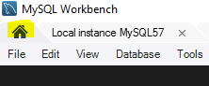

Next use the highlighted > and select “Create ERR model from script”



To create the diagram, click on

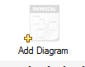

You will then need to drag tables from the Catalog Tree onto the Diagram. For example:

* Click the right mouse button on addresses in the clip below to select it. Click and hold the right mouse button over addresses, move to the Diagram area (blue pen), release the right mouse button and it will show addresses (red pen)

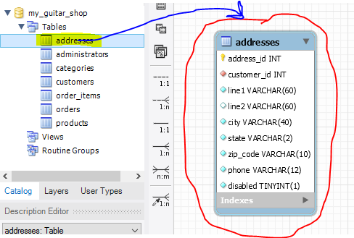

Repeat for the other tables, and drag to arrange the tables neatly like below

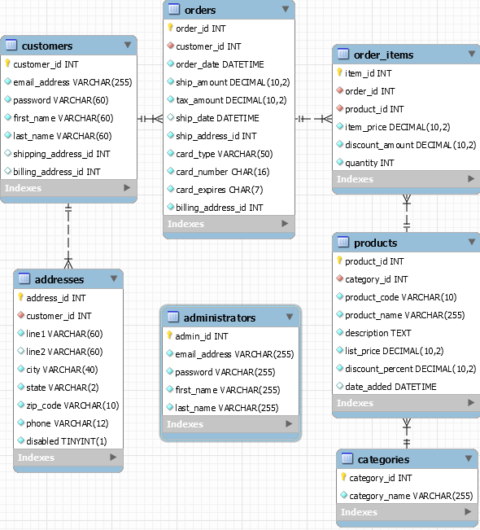

To save click on File and “save model” from the menu. Save to file as10-1. This will create a file as10-1.mwb. Submit it in Canvas.



Question 2.

First click on the highlighted home icon



Next click on the highlighted + icon



You can change the schema name by right clicking on



Then select “edit schema…” from menu. Then change from mydb to user_downloads

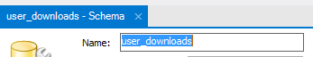

Next double left click on Add Table



Expand the size of the Table window, and add columns like below

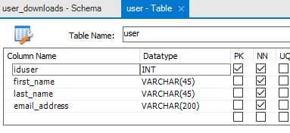

Add the table downloads with columns below

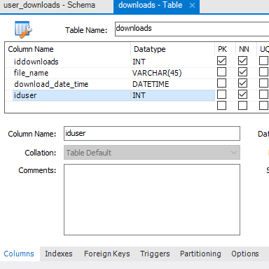

Specify a foreign key in downloads like below

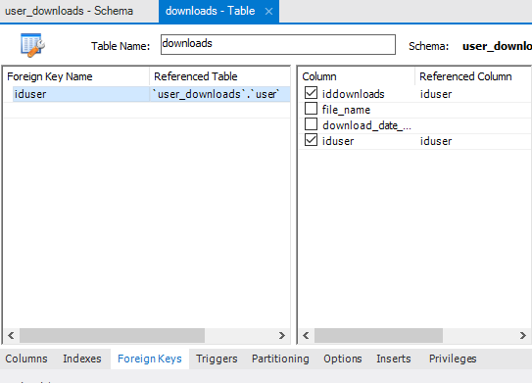

Next add the table products

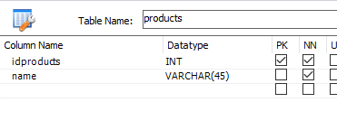

You will need to add idproducts as a second foreign key in the table downloads like below

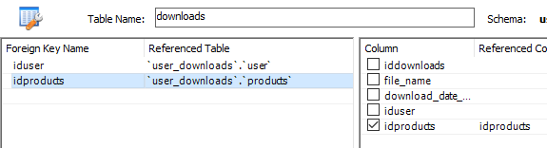

Add a diagram as in question 1, and save to file 10-2.mwb . Submit this file in Canvas.

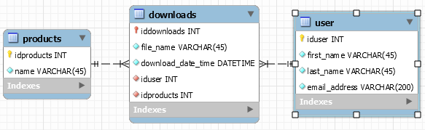

Question 3.

No hints. Save your result to a file 10-3.sql and submit it in Canvas.

Question 4, 5, 6.

Return your result as a hard copy file in class.

For the database below from the slides “Introduction to Normalization”:

|  |  |  |  |  |  |
| --- | --- | --- | --- | --- | --- |
| Order_id | Customer_name | Order_date | Item_id | Item_qty | Item_price |
| 125 | FooInc | 9/13/2002 | 563 | 4 | 3.50 |
| ·· | ·· |  | 851 | 32 | 0.25 |
| ·· | ·· |  | 652 | 5 | 12.00 |
| 126 | FreensRUs | 9/14/2002 | 563 | 500 | 3.50 |
| ·· | ·· |  | 652 | 750 | 12.00 |

The first normal form is

|  |  |  |  |  |  |
| --- | --- | --- | --- | --- | --- |
| Order_id | Customer_name | Order_date | Item_id | Item_qty | Item_price |
| 125 | FooInc | 9/13/2002 | 563 | 4 | 3.50 |
| 125 | FooInc | 9/13/2002 | 851 | 32 | 0.25 |
| 125 | FooInc | 9/13/2002 | 652 | 5 | 12.00 |
| 126 | FreensRUs | 9/14/2002 | 563 | 500 | 3.50 |
| 126 | FreensRUs | 9/14/2002 | 652 | 750 | 12.00 |

The second normal form is

|  |  |  |  |  |  |  |  |  |  |  |  |  |  |  |  |  |  |  |  |  |  |  |  |  |  |  |  |  |  |  |  |  |  |  |  |  |  |
| --- | --- | --- | --- | --- | --- | --- | --- | --- | --- | --- | --- | --- | --- | --- | --- | --- | --- | --- | --- | --- | --- | --- | --- | --- | --- | --- | --- | --- | --- | --- | --- | --- | --- | --- | --- | --- | --- |
| |  |  |  | | --- | --- | --- | | Order_id | Customer_name | Order_date | | 125 | FooInc | 9/13/2002 | | 126 | FreensRUs | 9/14/2002 | | |  |  |  | | --- | --- | --- | | Order_id | Item_id | Item_qty | | 125 | 563 | 4 | | 125 | 851 | 32 | | 125 | 652 | 5 | | 126 | 563 | 500 | | 126 | 652 | 750 | | |  |  | | --- | --- | | Item_id | Item_price | | 563 | 3.50 | | 851 | 0.25 | | 652 | 12.00 | |

Blue background = primary key, Red font = foreign key

The Third Normal Form is.

|  |  |  |  |  |  |  |  |  |  |  |  |  |  |  |  |  |  |  |  |  |  |  |  |  |  |  |  |  |
| --- | --- | --- | --- | --- | --- | --- | --- | --- | --- | --- | --- | --- | --- | --- | --- | --- | --- | --- | --- | --- | --- | --- | --- | --- | --- | --- | --- | --- |
| |  |  |  | | --- | --- | --- | | **Order_id** | **Customer_id** | **Order_date** | | **125** | **1** | 9/13/2002 | | **126** | **2** | 9/14/2002 | | |  |  |  | | --- | --- | --- | | **Order_id** | **Item_id** | **Item_qty** | | **125** | **563** | 4 | | **125** | **851** | 32 | | **125** | **652** | 5 | | **126** | **563** | 500 | | **126** | **652** | 750 | |
|  |  |
| |  |  | | --- | --- | | **Customer_id** | **Customer_name** | | **1** | FooInc | | **2** | FreensRUs | | |  |  | | --- | --- | | **Item_id** | **Item_price** | | **563** | 3.50 | | **851** | 0.25 | | **652** | 12.00 | |
|  |  |
|  |  |